CSAdmin

Deployment Guide

Date: 27/4/2018

Author: Brae Walker

# Installation and Setup

## Installation

### Pre-requisites

|  |  |  |  |
| --- | --- | --- | --- |
|  | Hardware | Software | Env & Other |
| Application Server | 120MB storage  4GM Ram  2.7GHz dual core | Windows Server 2008 or later  Version 4.5.2 of .NET  Framework  IIS 7 or later |  |
| DB Server | 3GB Storage (Provides space for at least 300 accounts)  4GM Ram  2.7GHz dual core | Microsoft SQL Server 2008 or later | There must be a linked server called Clara in the database being used. |

### Database Setup

For the database setup there are two paths that you could take.

1. New CSAdmin system.
2. Upgrading the CSAdmin System from original version to the current.

#### New CSAdmin Setup

This can be done by making a copy from our master copy. The master copy can be found on the SQL server CSDEV, it is named CSAdmin_Prod_MasterCopy. To copy this database to the correct location and rename it the following [wizard](https://docs.microsoft.com/en-us/sql/relational-databases/databases/use-the-copy-database-wizard?view=sql-server-2017) can be used, or a wizard corresponding to your database version can be used.

#### Upgrading

Upgrade scripts for the database have been created and sit in the “Database updates” folder. These can be run on the old version of the CSAdmin database to make the database run as expected.

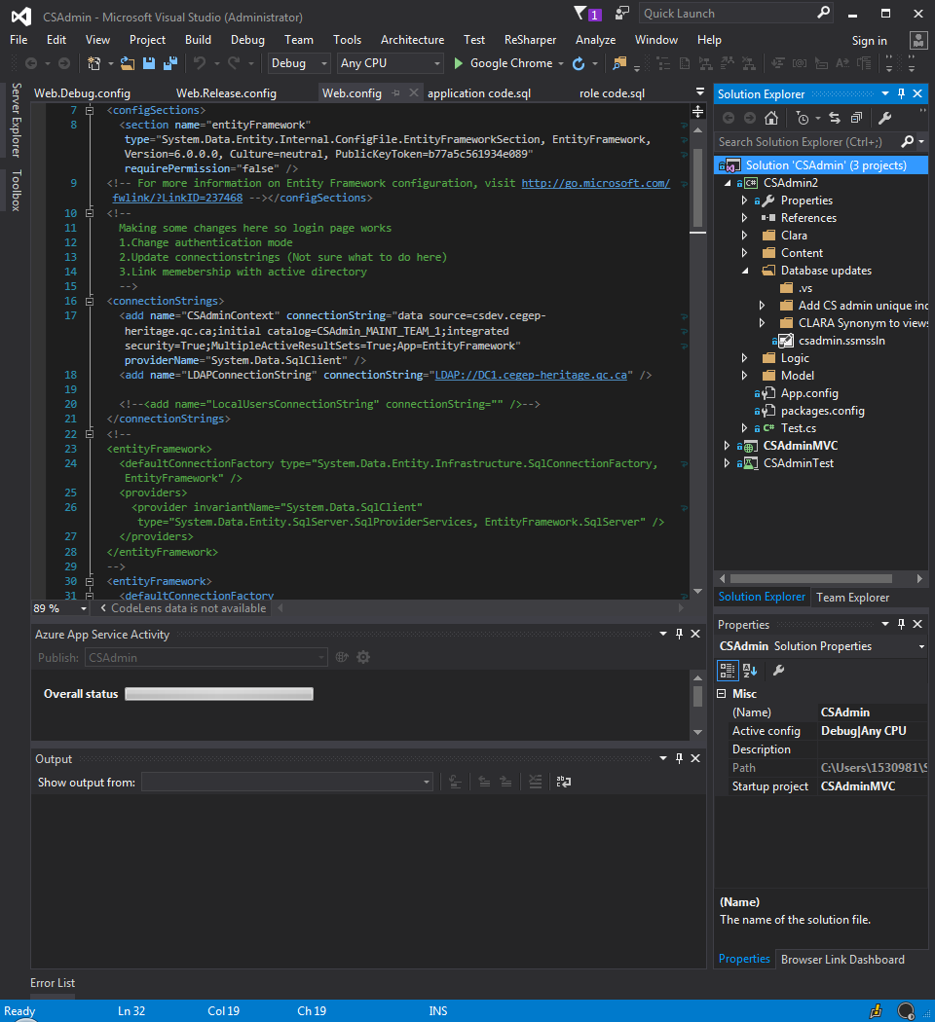

In the Database updates folder there are two subfolders with the scripts that need to be run. These scripts must be run one by one.

### Application server setup

1. First open the web.config file under the CSAdminMVC project.
2. In the web.config, change the connection string “CSAdminContext” data source to your new database. Also change the LDAP connection string to the correct URL.
3. Now you are ready to publish, right click the RAC project and select publish.

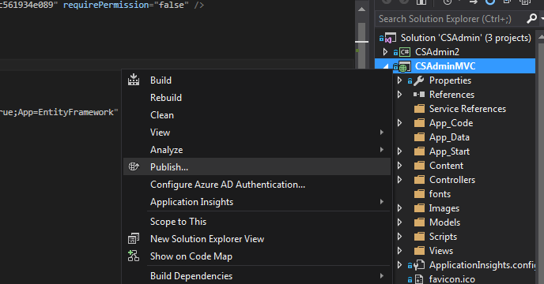

1. There should be publish profiles prepared that give you an idea of what your entry should look like.
2. Click the profiles dropdown and select “New Custom Profile”

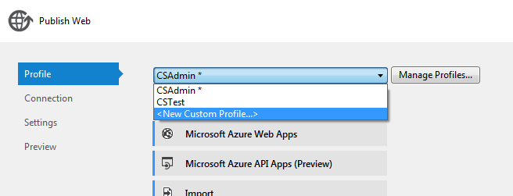

1. Fill in your server name and the site name followed by your credentials to the server you are using. You can confirm you have these credentials are correct by using the “Validate Connection” button.

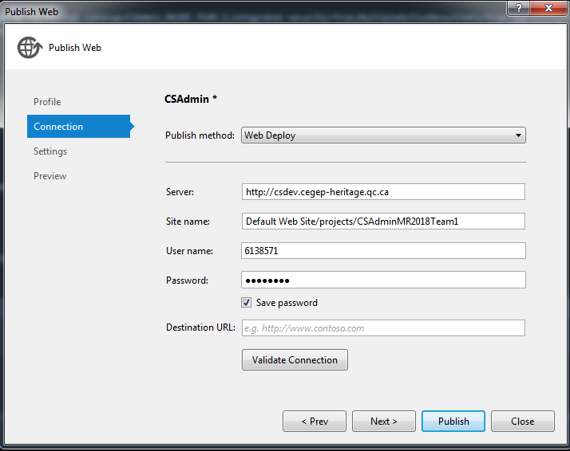

Now click publish. This should publish the application to the server.

### Adding App Pool

1. Log into IIS of your server machine, open IIS manager and locate the Application Pools section. Right click it and select to add an application pool.

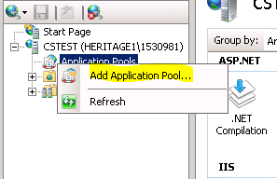

1. Enter the name of your choice with .NET Framework v4.0.30319 and “Integrated” as the managed pipeline mode.
2. Next, right click on your newly added Application Pool, select Advanced Settings and change the Identity to the identity that you are going to use. In our case, the identity will be called NetworkService.

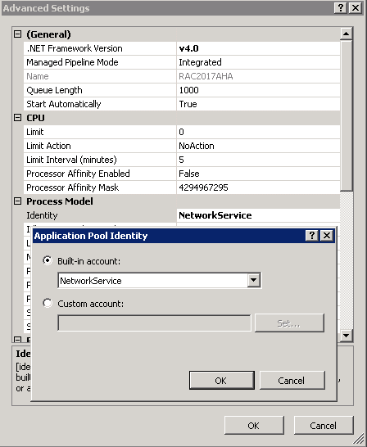

1. Add the RAC Application to your newly created Application Pool. This can be done by going to your website. Right Click -> Manage Application Advanced Settings. 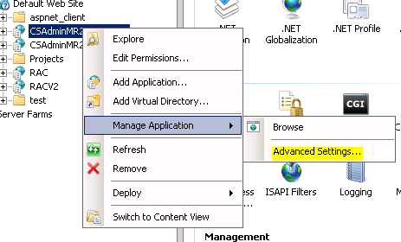
2. Change your application pool to the one you just added.